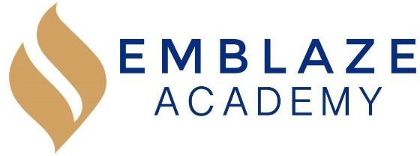
May 2021 Board Meeting Date: May 25, 2021.
Time: 6:30 PM - 8:15 PM.
Board Members in Attendance: | Absent Board Members: | Other Attendees:
Geraldo Vasquez  Tameka Beckford-Young  Janneth Gaona  Marlin Jenkins | Matthew Kirby-Smith | - Erienne Rojas  - Derian  - Francesca Lujan  - Ms.Mckeough  - E. Marku  - Korma  - Mr. Waller,  - Melissa- (old head of little bird)  - peter Dombrowski (w/ Melissa)  - MS. Hinton,  - Ronaire Morris  - Granger S.  - Stacey Chavez  - Tiana waller  - Virgina Croxtan  - Tiana Cruz  - Ipad  - Jasmine Gomez  - Dasmin Croft  - Rob (ADP)  - Hudson  - Adrian Gonzalez  - Kim Kalyins mom  - Collin Thompson  - Edyna Elya  - Mike Breem  - Floribel Rodriquez  - Anthony Birch (trinet)  - Miguel Pena
Location: Virtual meeting via https://us02web.zoom.us/j/83127516672 Meeting ID: 831 2751 6672 Password: ABC123
.
Time | Lead | Agenda Item
6:30- | Gerry | Call to order
6:30-6:40 | Gerry | Approval of Prior Meeting Minutes  - Mar 2021 Board Meeting  - July 2020 – Oct 2020; Dec 2020 and April 2021 Board Meetings
6:40-7:00 | Francesca | - PEO/HR Vendor Presentation (MELISSA OLD LITTLE BIRD) 6:40  - Emplova, is the company  - Prism HR is the program  - Benefits; signa metlife , pepm offer savings  - Tentative issues with managing payroll  - Paylocity plotform edtech was payroll lite  - Trinet model has their own trinet processing service-Edtech isn’t providing any services for payroll—head of school approval  - Edtech was only able to support through paylocity  - There is a fixed pricing structure that will be forthcoming
7:00-7:20 | Francesca | - PEO/HR Vendor Presentation ADP TEAM –Rob 7:00  - Hudson also part of team  - Benefit renewal tied to fiscal year currently in October  - Leader in payroll, customer support, tech, certified PEO  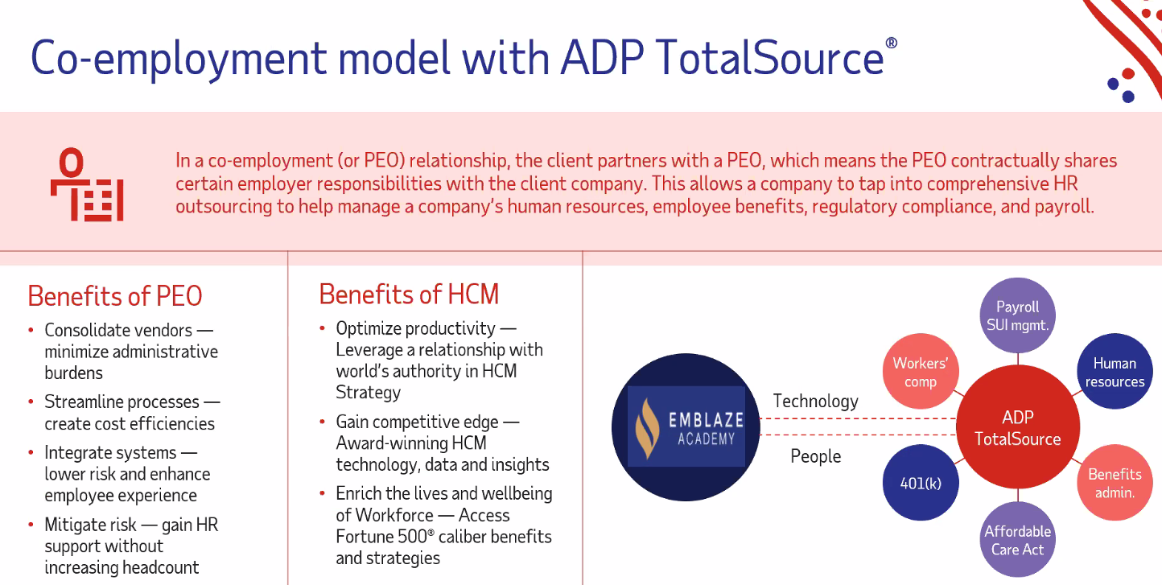  - Single digit renewal—underwriting upfront makes it cheaper—claims then adjustment  - These internal systems is a single services// concept of pooling  - Pull liability///certified PEO eliminate backend cost// workers comp cost is significantly less about $10,000
7:20-7:40 | Francesca | - PEO/HR Vendor Presentation 7:30 Anthony Birch –Trinet and Joanna  - Transition has added work to the staff load/ been having a difficulty with the work  - Shortfalls in servicing that are currently received --Diana is support on the payroll side  - There is currently no direct integration of retirement benefits  - Is there a trinet preferred -Transamerica- that would be automated retirement plan is currently handled by someone
7:40-7:50 | Gerry/Derian (Edtec) | Finance and Facilities Committee Report use docs for this 7:50  - April 2021 Financial Results  - PPP Forgiveness Update  - FY 2022 Budget Update
7:50-8:00 | Francesca | Management Report 7:56  - May 2021 Update  - 300 students for 2021-2022  - Reopening Plan Update
8:00-8:05 | Francesca | Review and Vote: Tabled till next board meeting  - $35,000 Furniture Purchase for New Grade (8th)
8:05-8:10 | Marlin | Enrollment and Development Committee Report  - Enrollment Update  - Development Update  - Branding Program
8:10-8:15 | Gerry/Tameka | Governance Committee Report Tabled  - Board Candidates Status  - 1 candidate in final phase of review  - 2 candidates under review
8:15 | Gerry | Adjournment adjourned at 812

We will be having another special board meeting

