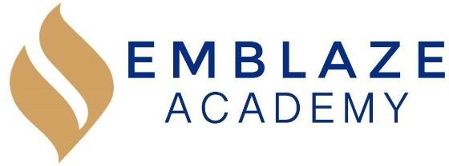
June 2021 Board Meeting Date: June 30, 2021.
Time: 6:30 PM - 8:15 PM.
Location: Virtual meeting at meet.google.com/jgi-uoay- zfq.

Board Members in Attendance: | Absent Board Members: | Other Attendees:
Geraldo Vasquez  Tameka Beckford-Young  Janneth Gaona  Marlin Jenkins  Elizabeth Goana  Matthew Kirby-Smith |  | Elizabeth Marku  Jasmine Gomes  Kaitlyn McKeough  Megan Ricigliano  Collin Thompson  Tiana Waller  C. Rhodes

Time | Lead | Agenda Item
6:30/6:40 | Gerry | Call to order  Intro of Elizabeth Gaona  Motion to serve as treasurer, also finance and facilities chairperson committee  - Approved Unanimously
6:30-6:40 | Gerry | Approval of Prior Meeting Minutes (Will be discussed next meeting)  - May 2021 Board Meeting  - July 2020 – Oct 2020; Dec 2020 and March 2021 – April 2021 Board Meetings
6:40-7:00 | Gerry/Derian (Edtec) | Finance and Facilities Committee Report (Will be discussed next meeting)  - June 2021 Financial Results  - FY 2022 Budget Update
7:00-7:30 | Francesca | Management Report Using a baseline need clarification on this  - June 2021 Update  - Reopening Plan Update
7:30-8:00 | Francesca/Gerry/ Derian (Edtec) | Review and Vote:  - $35,000 Furniture Purchase for New Grade (8th)  - FY 2022 Budget  - Primary items are Salary and rent  - Salary: proposed escalations from HoS, board is looking to bring on a consultant to review salaries across board, to make sure they are marketable and equitable  - Current budget doesn’t have a lot of leeway for these changes—proposed contingency for salaries  - Gerry moves to tentative approval of the budget, soft approval, pending certain modifications; approved unanimously  - Insurance Renewal  - Two main points increase of 10%+, covid related spikes, this does not include cybersecurity (previously $63). (Need bids for this)  - All commutable diseases (COVID), new policy does not cover if we are liable and get sued. State educational entity, the only change is if there has been some shortsightedness on the school’s part then we are not covered. We have access to lower rates because of our participation in board pool. (Negligence)  - Increase in policy and cybersecurity policy may increase and still needs to be renegotiated, we are still looking for COIVD related policies  - Approved Unanimously  - More COVID protocols to come from the State and city level for the Charter school division  - Audit Firm Renewal  - 13,000 audti fee plus 1500 tax  - Engagement letter for auditing  - We want agreement separate from tax services and management services  - Motion the approval of the audit who is external pending multiyear agreement and tax information (990 tax number)  - Approved Unanimously
8:00-8:05 | Marlin | Enrollment and Development Committee Report (Will be discussed next meeting)  - Enrollment Update  - Development Update  - Branding Program
8:05-8:15 | Gerry/Tameka | Governance Committee Report  - Welcome New Board Member  - Prior to previous meeting there were discussions had with staff and parents  - Several staff have reached out to the board, unable to have collective meeting  - HR team is looking to provide the board with proposals with how to communicate complaints with broken down steps (formal complaints)  - A written policy and procedure is being created for compliant process  - Specific individuals with issues, and some anonymous issues to address as well  - Legal is addressing this, emails have been responded to, currently working to create an approach for this also an updated policy for this
8:15 | Gerry | Adjournment

