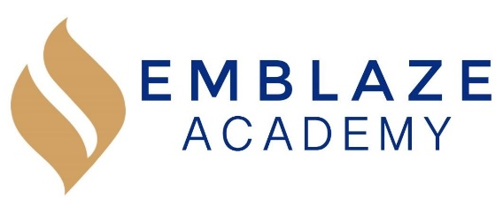 | Board Meeting  Date: January 8, 2020.  Time: 6:30 PM - 8:15 PM.  Location: Video conference via https://zoom.us/j/6671132491.
Board Members in Attendance: | Absent Board Members: | Other Attendees:
Geraldo Vasquez, Board Chair  Rosann Santos, Vice Chair  Tameka Beckford-Young, Secretary  Harini Mittal, Treasurer  Matthew Kirby-Smith  Raghav Thapar  Marlin Jenkins |  | Kristen Shroff, Head of School  Erienne Rojas, Director of Operations
Time | Lead | Agenda Item
6:30 | Gerry | Call to order
6:30-6:35
6:35-7:00 | Kristen | Management Report  January 2020 Update  - Family Survey Results  - The first report Card Afternoon was held where the initial round of 19-20 surveys from the families were taken. On December 12th, 2019, the overall results seem to be that the families are pleased.  - Overall Positive responses families are appreciative of the open line of communication, parents reported that they were impressed by the academic rigor of the program.  - NEXT STEPS: families that rated the school a ‘C’ or better will be followed up with about things they wish to see done better. Some families expressed interest in the PTA, we will reach out to them and set up an open line of communication.  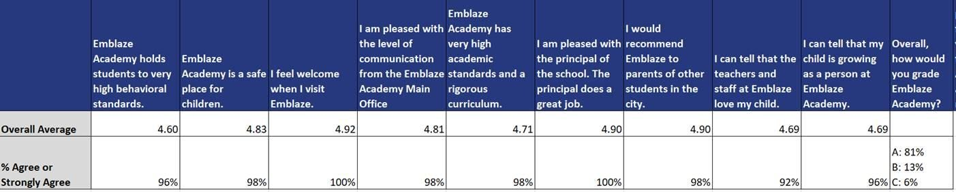  - Organizational Health Survey Results  - The team took their first health survey the last week before winter break. Erienne and Kristen met with each staff member individually and got their feedback and input on how the school year has been so far.  - Results of this survey have been positive overall; the team feels successful and that they are accomplishing the school’s mission and that all members of the team put the student’s needs first. Staff members enjoy working together and overall the team is invested in the Emblaze mission.  - NEXT STEPS: Erienne and Kristen are going to do a re-set with the Deans about the pros and cons of coaching vs. managing. As well as have discussions on how to best set up teachers to be successful with their students by providing structured inputs, and tips for team leads.  - Peer Review Surveys  - The team took peer surveys and 360 surveys on Kristen, Erinne and the Deans. The results were distributed individually to the teachers first week back from break.  - The trend is overall positive the team members seem to have a lot of respect for the students and are committed to outputting quality work.  - NEXT STEPS: The staffing plan moving forward is to encourage the teachers to take on more leadership roles in areas that interest them in hopes that if more opportunities are provided to step up they would want to. There are of course outliers in the High and low regions, those in the high region will be considered for more leadership roles. Where those on the low region will be considered for PIP and a formal conversation will be had about this.  - Employee Issues  - One of the counselors was placed on probation  - She was a high performer during the last academic school year, but has had performance and interpersonal issues during the current school year, including gossiping, and calling an African-American colleague “hood”  - Many of the parents have complained about the employee and have stated that they don’t want to interact with employee  - As a result of the of the “hood” comment, a colleague filed a formal complaint on 1/8/2020  - The Employee was placed on a performance improvement plan in early December 2019 and within 4 days of beginning the PIP received a complaint.  - The PIP period concludes the week of 1/31 and management will be sure to have Little Bird (HR consultant) attend the meeting with the colleague.
7:00-7:30 | Harini | Finance and Facilities Committee Report  - November 2019 Financial Results  - Financial results not yet ready: To be presented at subsequent board meeting  - The school has $7K cash on hand.  - Tax Report Update – status update provided.  - Facilities Update
7:30-7:55 | Gerry | Governance Committee Report  - Succession Planning – Selection of New Board Chair  - Committee Meetings – New dates and timeframes  - Board Member Job Descriptions Status (Updating)  - Recruiting Platforms (Reviewing)
7:55-8:10 | Rosann | Compensation Committee Report  - 2019-2020 HOS Objectives  - Review Timeframe(s)  - Assessment Matrix Update
8:10-8:15 | Gerry | Next Steps  - Committee Objectives and Meetings  - Outstanding Items  - HOS DEPARTURE  - HOS is leaving for personal issues  - The board considered the following questions in light of the news:  - Can Erienne take over the HOS role and oversee the 3 directors.  - Would Kristen want to be or could serve Board Chair?  - Would Kristen consider taking an open ended leave instead of resigning?  - HOS proposals to stay involved with Emblaze  - Board chair – serve in this capacity as she knows the board and school really well  - She could also serve as a consultant for the school  - HOS explained that an Executive Director does not have to have academic background to serve in this capacity; this is not uncommon.
8:15 | Gerry | Adjournment

