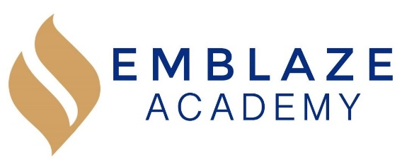 | Board Meeting  Date: December 4, 2019.  Time: 6:30 PM - 8:15 PM.  Location: Video conference via https://zoom.us/j/6671132491.
Board Members in Attendance: | Absent Board Members: | Other Attendees:
Geraldo Vasquez, Board Chair  Rosann Santos, Vice Chair  Harini Mittal, Treasurer  Tameka Beckford-Young, Secretary  Matthew Kirby-Smith  Raghav Thapar  Marlin Jenkins |  | Kristen Shroff, Head of School  Erienne Rojas, Director of Operations
 | Lead | Agenda Item
 | Gerry | Call to order
 | Kristen | Management Report  December 2019 Update  - Second round of student surveys were conducted on Nov 15, 2019  - the surveys allowed students to access three teachers individually  - The overall results were good, and moving forward teachers would like to give the students more opportunities to collaborate with their peers during class time  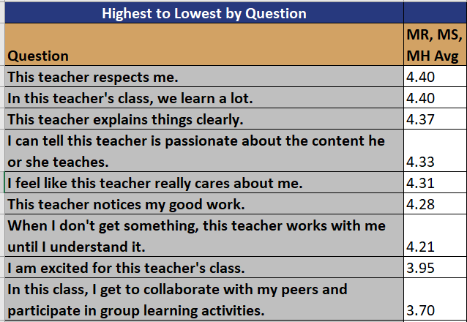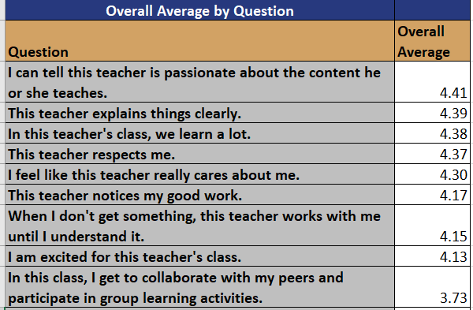  - Second Interim assessment was taken the week before Thanksgiving  - The assessment’s Data is accessed in two parts:  - The percent correct (the overall score on the assessment)  - The percent proficient (the percent of students who scored 70% and above  - This provides an accurate estimate as to whether the student is performing at grade level, and is a good indicator of the student’s performance on NYS exams.  Overall takeaways from the data:  - 5th (Math) is on track; strong results and growth  - 5th (ELA) is not on track; need more focus on multiple choice (revising Close reading structure including more multiple choice at bats in literature)  - 6th (Math) partially OnTrack; percentage correct was strong, but proficiency, need more focus on mid &mid-high students to ensure their growth  - 6th (ELA) is on track; super strong growth here, need to keep the momentum going  - Students with IEPs and ELLs are growing at a faster rate than their general education peers  - Students who began the year significantly below the grade level are growing very quickly across all content areas  - The rigor of the curriculum needs to continue.  - Feedback to the mid and high students needs to continue to ensure their continued growth  Faculty Update  - New Dean of Curriculum and Instruction for Literature & Writing started in December 2019. Was on maternity leave since July; the team loves her and things are going well. She has many innovative ideas for the ELA department.  - Lost a stem specialist who was offered a full-time professor job while perusing her PhD. She has been replaced.  - Two STEM specialists were hired this year  - Jasmine Bridges (taught at Harlem Village Academics) will support as a co-teacher for the science classes and 6th grade Math  - Remy Guerrero (a fellow) will support 6th grade math as well as History as current specialist is on maternity leave  - Security Guard (Chris Rivera) resigned form Arrow security, school is planning to hire him full time as a Security Guard and Facilities Manager  - A current employee is on a Performance Improvement Plan (PIP) in consultation with Little Bird HR. The particular emplotee is working on fostering positive relationships and productive communication in the workplace and communicate effectively with members of the school community through in person and electronic methods. (Performance must improve to avoid termination)  - Hiring for the 2020-2021 school year has begun, it is anticipated that 14 new staff members will be hired
 | Harini | Finance and Facilities Committee Report  October2019 Financial Results  - Budget vs Actuals (revenues)  - In October, Emblaze received its third per pupil payment (3 of 6) for Nov-Dec.  - $16k in federal grants from E-Rate funding.  - Budget vs actuals (expenses)  - Large negative variance in Administrative Expenses is due to Furniture and Computer purchases. This will be capitalized, and variance will decrease.  - Budget YTD vs Actual YTD  2019-20 2019-20 Variance  Revenue Per Pupil Funding & State Grants Budget YTD 1,672,261 Actuals YTD 1,533,111 (139,150)  Federal Grants 38,852 16,204 (22,648)  Contributions & Grants - - -  Fundraising - - -  Interest - 54 54  Miscellaneous Revenues 33,333 305 (33,028)  Total Revenue 1,744,446 1,549,674 (194,772)  Expenses Personnel 571,730 484,192 87,538  Benefits & Insurances 130,670 92,913 37,756  Curriculum & Classroom 12,167 9,602 2,565  Administrative Expenses & Insurances 51,445 264,741 (213,296)  Professional Development & Services 86,548 96,234 (9,685)  Marketing & Recruitment 6,333 7,301 (967)  Facilities 639,458 618,831 20,627  Miscellaneous Expenses 39,947 46,437 (6,490)  Total Expenses 1,538,298 1,620,250 (81,952)  Operating Income 206,148 (70,576) (276,724)  Beginning Balance (Audited) - 743,556 743,556  Operating Income 206,148 (70,576) (276,724)  Ending Fund Balance (incl. Depreciation) 206,148 672,980 466,833  Ending Fund Balance as % of Expenses 13.4% 41.5% 28.1%
 | Marlin | Enrollment and Development Committee Report  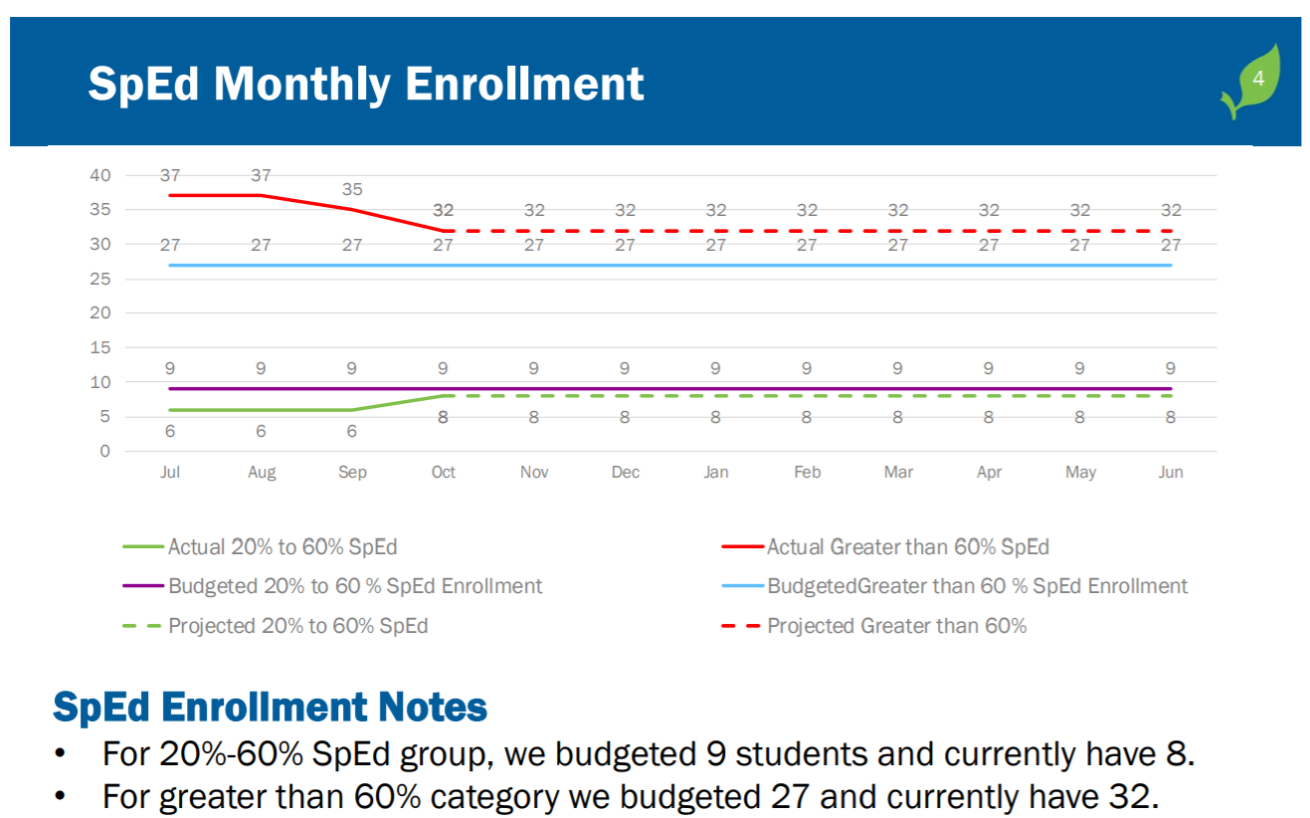
 | Gerry | Governance Committee Report  - Succession Planning – Selection of New Board Chair  - Committee Meetings – New dates and timeframes  - Board Member Job Descriptions Status (Updating)  - Recruiting Platforms (Reviewing)
 | Gerry | Next Steps  - Committee Objectives and Meetings  - Outstanding Items
8:15 | Gerry | Adjournment

