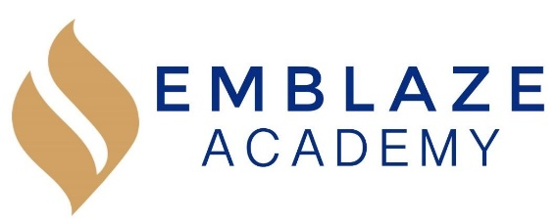 | Board Meeting  Date: August 14, 2019.  Time: 6:30 PM - 8:15 PM.  Location: Video conference via https://zoom.us/j/6671132491.
Board Members in Attendance: | Absent Board Members: | Other Attendees:
Geraldo Vasquez, Board Chair  Rosann Santos, Vice Chair  Tameka Beckford-Young, Secretary  Harini Mittal, Treasurer  Matthew Kirby-Smith | Raghav Thapar  Marlin Jenkins | Kristen Shroff, Head of School  Erienne Rojas, Director of Operations
 | Lead | Agenda Item
 | Gerry | Call to order
 | Rosann | HOS Compensation & Bonus for 7/01/2019 to 6/30/2020
 | Kristen | Management Report  August 2019 Update  - Student Recruitment  - Overall, we have had 464 applications for the 2019-2020 school year and our current enrollment status is:  - 5th Grade (28 more seats to fill)  - 61 families accepted and officially enrolling  - 0 offers out  - 0 families on the waiting list  - 6th grade: (17 more seats to fill)  - 23 families accepted and officially enrolling  - 13 offers out  - 145 on the waiting list  - Management is 100% confident that we will get all of our 6th grade seats filled given the high number of students that we have on the waiting list.  - Management is a little worried about 5th grade enrollment and have taken the following steps:  - A new mailer went out to families in the neighborhood advertising the school and how to enroll  - A large sign was put up in front of the building  - The team has been canvassing the neighborhood, dropping off flyers at the local community board, community centers, and afterschool programs.  - Management will continue to monitor 5th grade enrollment closely and keep the boarrd updated.  - Hiring & Staff Culture  - The Leadership and Operations Teams returned from summer break on July 15th. The teams reviewed, tweaked, and normed every element of our school including goals, calendar, schedule, handbooks, arrival, dismissal, breaks, homerooms, electives, academic systems, student attendance, student organization, homework, and many more.  - HOS coached the team on our instructional rubric, teacher coaching, people management, and leading PD.  - Teachers began training on August 5th. August Teacher Professional Development includes 95 sessions on our academic systems, behavior system, student culture systems, policies, and adult culture.  - Our first day of Student Orientation is August 21st and our first full day with students is Monday, August 26th.
 | Harini | Finance and Facilities Committee Report  June 2019 Financial Results  - Budget YTD vs Actual YTD  - Total Revenue: $3,121,614 vs. $3,489,825  - Total Expenses (adjusted): $ $2,753,588 vs. $2,864,292  - Operating Income (Loss): $327,462 vs. $625,533
 | Gerry | Governance Committee Report  - Succession Planning – Selection of New Board Chair  - Board Member Job Descriptions Status (Updating)  - Recruiting Platforms (Reviewing)
8:15 | Gerry | Adjournment

